CS 242 Final Project

Week 0

Manual Test Plan

1. Download the source files and open them in an IDE (e.g. Eclipse).
2. Use the test file in the main method or select your own music file.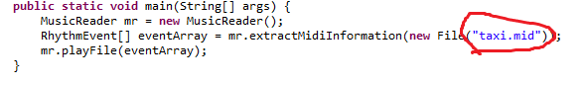

In order to use your own mp3 files, use <http://www.ofoct.com/audio-converter/convert-wav-or-mp3-ogg-aac-wma-to-midi.html> or a MP3 to MIDI converter of your choice.

1. Run the program. The output should progress according to the timestamps. Compare with the music and note that the high notes of the song correspond to the peak velocities of the output. Using the test file “taxi.mid”, note that the four triplet beats in the song at around 0.5s, 2.5s, 4.5s and 6.0s are represented in the output, with significantly higher velocity than the surrounding notes. See the image below:

